Contents

Task 1 – Construct the Design Steps 2

1.1 Sequence 2

1.1.1 Sequence Diagram Step 2

1.1.2 Instance Sequence Diagram Steps: 3

1.2 Activity 6

1.2.1 Activity Diagram for Business Modelling Steps 6

1.2.2 Activity Diagram for Use Case Modelling Steps 6

Task 2 – Design the Diagram 7

Sequence Diagrams 7

Restaurant Management System – Manager – Sequence Diagram 7

Restaurant Management System – Customer – Sequence Diagram 8

Activity Diagrams 9

Restaurant Management System – Business – Activity Diagram 9

Restaurant Management System – Use Case – Activity Diagram 9

# Task 1 – Construct the Design Steps

## 1.1 Sequence

### Sequence Diagram Step

1. The task is to decide on the context of the Restaurant Management System (RMS) sequence diagrams. This is the use case: Inventory management & Ordering foods. The sequence diagrams will be produced the context of the collaboration that realizes the use case.
2. The collaboration involves objects from the classes Customer, Manager, Account, Membership, Food orders, Reservation, and Promotion. Each customer has one account, it associates with membership and promotion. If the customer account is not a member will not have the promotion offer during ordering foods. Besides that, each food item in the menu may have promotion that different from membership promotion. Which mean there has two types of based promotion will affect the total price of the bill.
3. Possible alternative scenario:
   * Customer order foods without account.
   * Customer as a member order food, but no promotion or given a non-member promotion.
   * Manager may not add any promotion in both membership and non-membership.

### Instance Sequence Diagram Steps:

Customer:

1. Figure 1 shows the objects from left to right.



Figure 1: Customer sequence diagram objects

1. Layout message down the page.
2. Customer open / renew membership
   * When customer login their account will validate membership through system.
   * If user is a member, system will prompt to ask user choose to renew membership or not. If user choose to renew, system will update it and link to account.
   * If user is not a member, system will prompt to customer to choose need to register as a member or not. If user choose to register, system will update it and link to account.

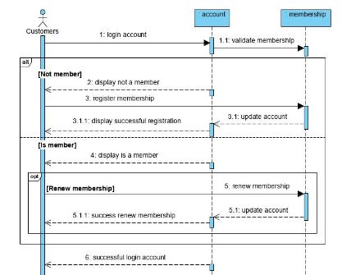

Figure 2: Customer login & validation of membership

1. Customer reservation

* After user login, customer will check their reservation.
* If has reserve a table, customer can choose to cancel it or not.
* If didn’t reserve a table, system will show available table to let customer choose to reserve.

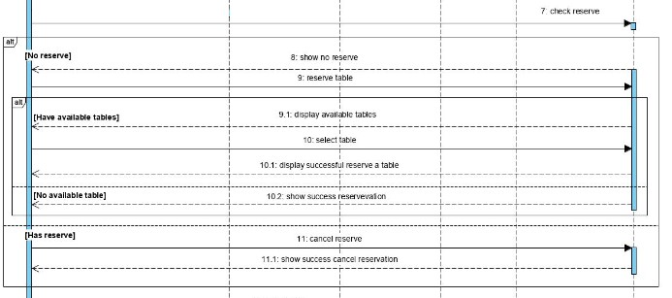

Figure 3: Customer reservation

1. Customer ordering

* Customer orders food, system will total up the price.
* System will refer to customer account and check membership. If it is member, system will discount the price of the foods.
* System will refer to promotions for non-member customer. If has, system will discount the price of the foods.
* System generate bill, and customer pay by cash or credit card.
* System generate receipt and return to customer.

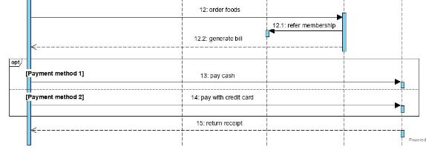

Figure 4: Customer ordering

Manager:

1. Figure 5 shows objects from left to right

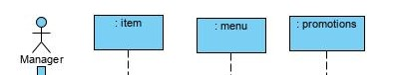

Figure 5: Manager sequence diagram objects

1. Layout message down the page.
   1. Manager manage item
      * Manager add item to system.
      * Manager edit item detail in system.
      * Manager remove item from system.
   2. Manager manage menu
      * Manager add item to menu.
      * Manager add price for the item in menu.
      * Manager edit menu.
      * Manager remove item from menu.
      * Manager remove menu.
   3. Manager manage promotion
      * Manager add promotion.
      * Category of promotion has two type which are member promotion and non-member promotion.
      * Non-member promotion will link to menu or particular item.

## Activity

### Activity Diagram for Business Modelling Steps

1. Business actor will be Manager. The use case is RMS Inventory system.
2. identifying key scenarios of business use cases:

* Primary path
  + Manager manage food item inventory.
  + Manager manage menu.
  + Manager manage price of the food item in menu.
  + Manager manage promotion.
* Alternative path
  + Food item maybe empty.
  + May have no promotion.

### Activity Diagram for Use Case Modelling Steps

1. Identifying key scenarios of system use cases:

* Primary path
  + Customer can login account.
  + Customer can open or renew membership.
  + Customer can reserve or cancel a table.
  + Customer can order foods.
  + Customer can have promotion discount, it depends customer is a member and current season promotion.
  + Customer can pay with two kind of payment method, which are cash or credit card.
* Alternative path
  + May have no available table to reserve.
  + May have no non-member promotion in the season.

# Task 2 – Design the Diagram

## Sequence Diagrams

### Restaurant Management System – Manager – Sequence Diagram

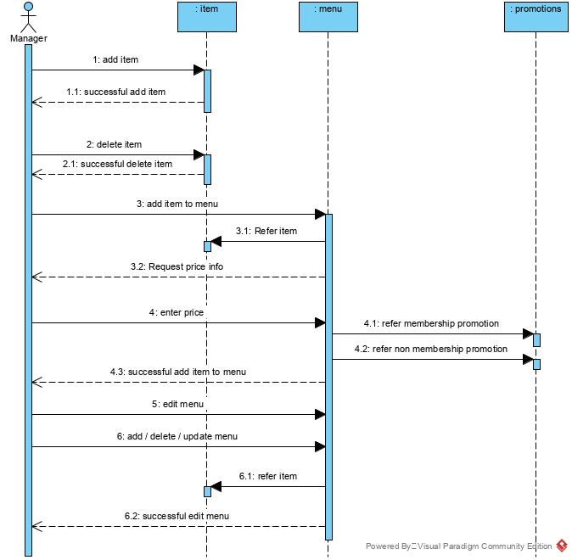

### Restaurant Management System – Customer – Sequence Diagram

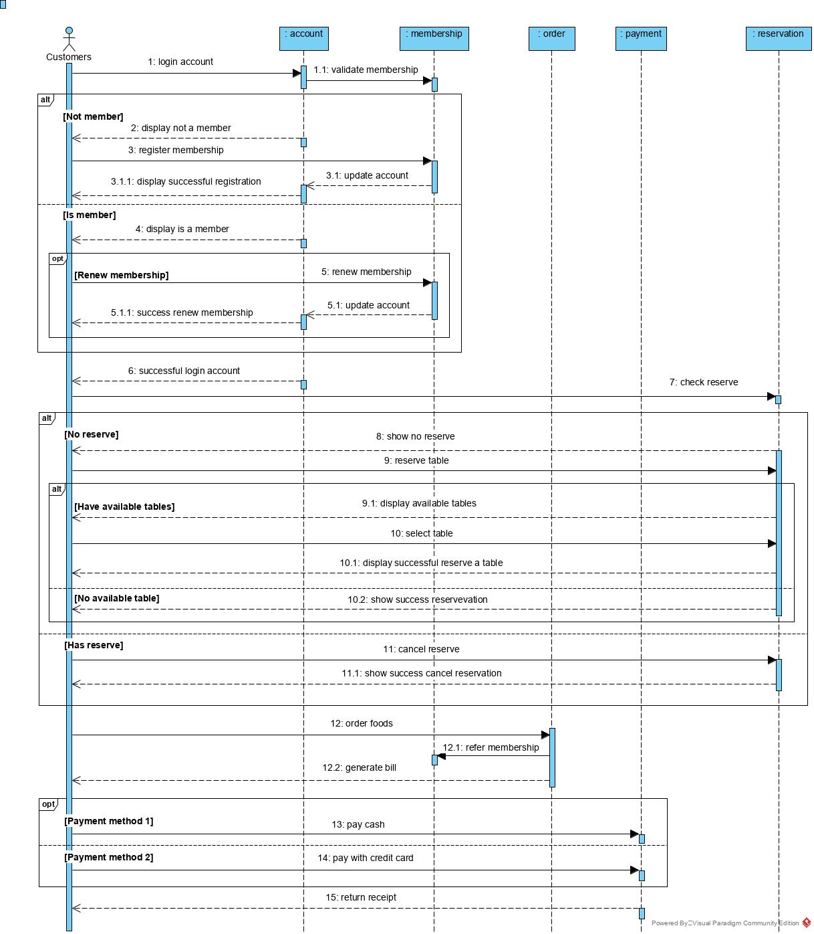

## Activity Diagrams

### Restaurant Management System – Business – Activity Diagram

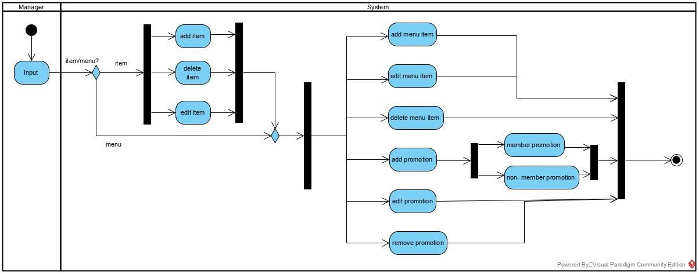

### Restaurant Management System – Use Case – Activity Diagram

